**IFT 266 Introduction to Network Information Communication Technology (ICT)   
  
Lab 49**

**Implement IPV6 Network with Packet Sniffer**

Co-authored by Jorge Elizarraras

**After you complete each step, put a ‘√’ or ‘x’ in the completed box**

**Or**

**Insert a screenshot where required.**

**Objective:** Introduce you to the Packet Sniffer.

1. Set up the following topology in packet tracer.

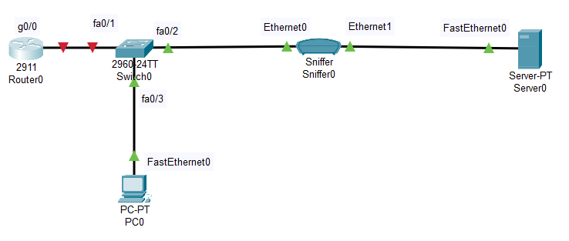



1. Enter the following commands onto the router as we will use unicast routing

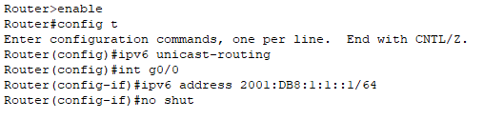

Note: at this point all links should be green. If not, troubleshoot.



1. Go to PC0 and Server0’s IP Configuration tool and enable Auto Config. You should get IPV6 addresses at this point, if not troubleshoot.



1. Ping Server0 from PC0. If you do not get a ping, then troubleshoot.  
     
   Insert a screenshot of your successful ping below.
2. Click on Sniffer0 and go to the GUI tab and the button “Show All/None”. This should clear all visible

events.

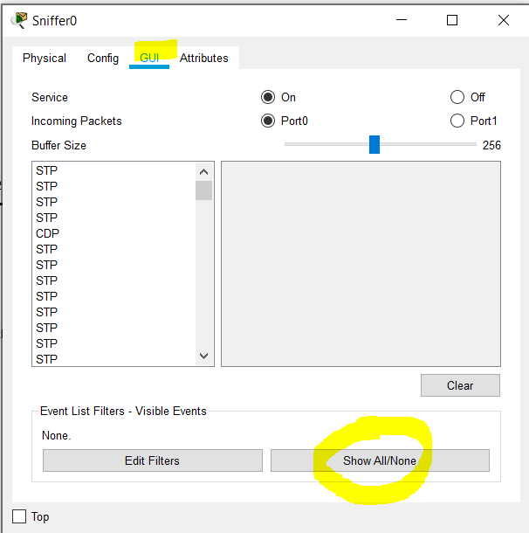



1. Click on the “Edit Filters” button and check “HTTP” in the Misc tab.

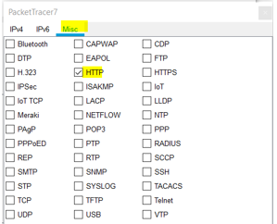



1. Open PC0’s browser and type in Server0’s IPV6 address in the URL field and append “:80” to the end of the IP address.   
     
   You should see a website like in the example below:

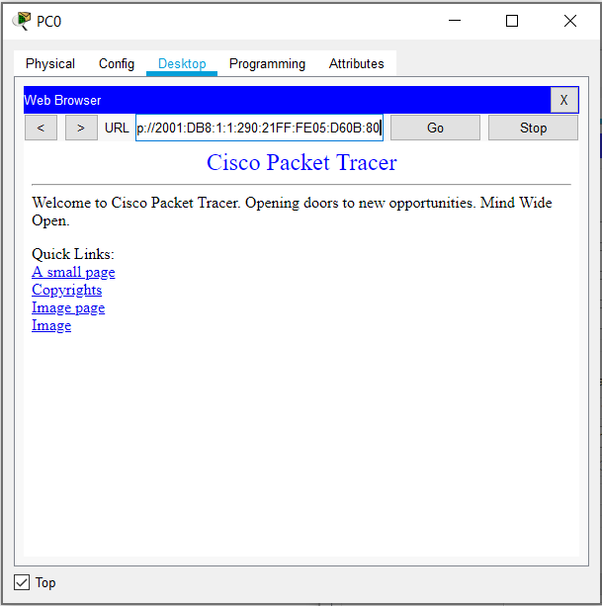



1. Open the Sniffer0 device and go to the GUI. You should see an incoming HTTP packet.   
     
   It may appear at the end of the list if other protocols are on by any chance like STP.

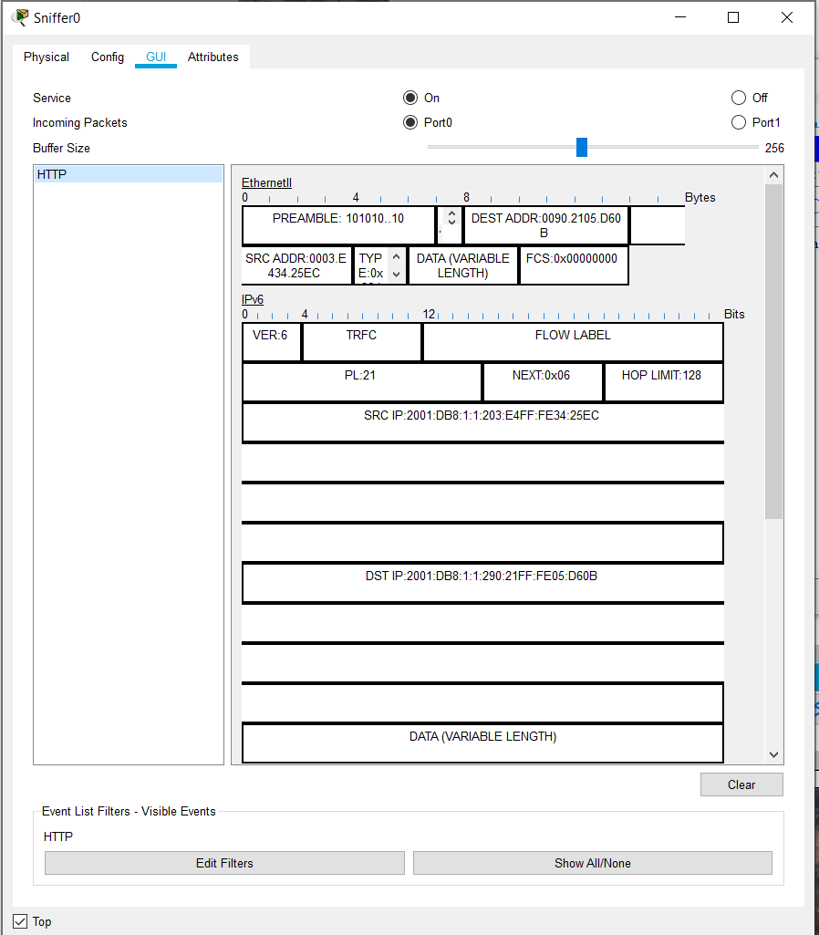



1. Click inside the packet and check out the fields that we looked at previously.

